**Read Me**

Mainly based ZegCLIP open source：

（1）ADE20K dataloader：configs/_base_/datasets/dataloader/ade20.py

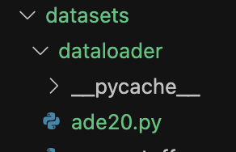

Get classes names embeddings of ADE20K from CLIP encoder: configs/_base_/datasets/text_embedding/get_embedding.ipynb

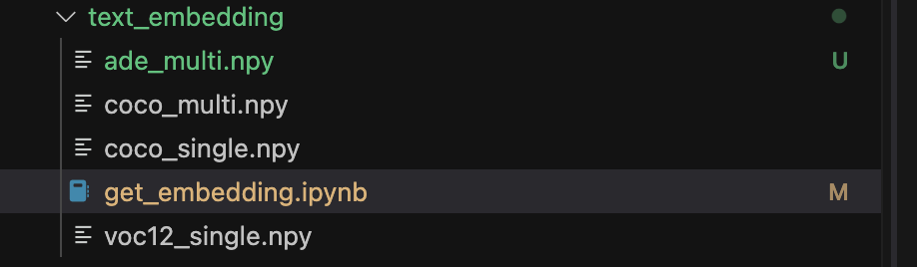

The results is saved at configs/_base_/datasets/text_embedding/ade_multi.npy

(2) Running config on ADE20K:

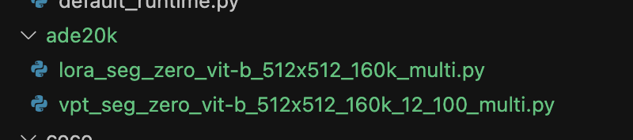

1. Baseline (ZegCLIP method): configs/ade20k/vpt_seg_zero_vit-b_512x512_160k_12_100_multi.py
2. Improved (this project): configs/ade20k/lora_seg_zero_vit-b_512x512_160k_multi.py

(3) Method update:

1. Main Class: models/backbone/img_encoder.py

1. The reliable Classes of LoRACLIPVisionTransformer are written in:

models/backbone/loralib.py

models/backbone/utils.py

(4) Follow the README.md to create conda environment, and then run:

Training:

1. bash dist_train.sh configs/ade20k/vpt_seg_zero_vit-b_512x512_160k_12_100_multi.py ./checkpoint/baseline
2. bash dist_train.sh configs/ade20k/lora_seg_zero_vit-b_512x512_160k_multi.py ./checkpoint/improved

Testing:

1. python test.py configs/ade20k/vpt_seg_zero_vit-b_512x512_160k_12_100_multi.py ./checkpoint/baseline/latest.pth –eval=mIoU
2. python test.py configs/ade20k/ lora_seg_zero_vit-b_512x512_160k_multi.py ./checkpoint/baseline/latest.pth –eval=mIoU